1. Create project like the following figure:

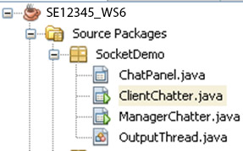

1. Design the GUI like the following figure**(10 marks)**

2 staffs and manager – when 2 connections is established

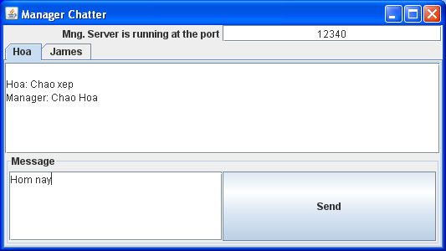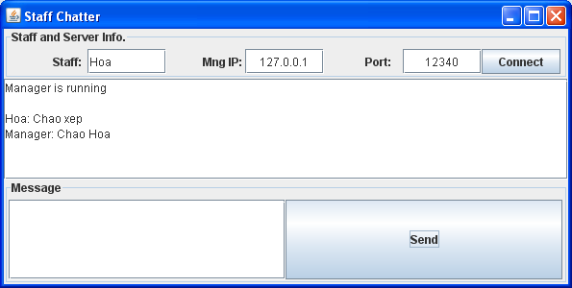

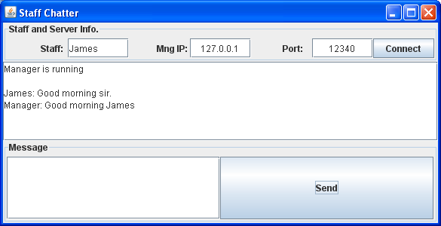

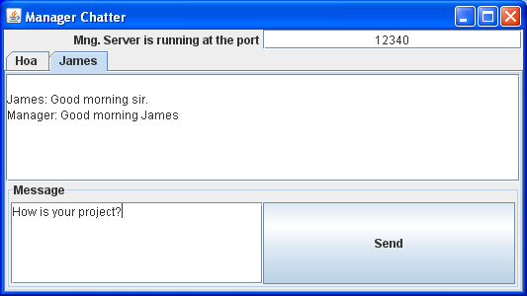

Performance requirements:

Using Java TCP Socket create chat program as described above.